Posting the Daily Apartment/Job Listings to ACC’s Website
- Go to https://www.squarespace.com/ (get login info from Hwei-Ling)
In the sidebar click pages > scroll down to resources > “Job & Apartment Listings”
- Click the + button up top in the sidebar by the title and gear
- Title: “Job listings/Room Listings”, follow the format on the page
- To include the image
  - Click the black/grey droplet that should appear next to every line (for our purposes, click whichever one is underneath the text you’ve written)
  - Click image
  - Click add an image and select the listing from your computer
  - Check off “lightbox” which allows the image to be enlarged
  - Hit apply and you’re done!
- If you’ve completed the post, click save & publish
- If you’re not completely finished but would like to save the post as a draft to finish later, just hit save (do not publish anything unfinished please!)
- To share to Facebook:
  - Click “photo/video” above the status box, upload a relevant photo.
  - OR create a new status and then click the small camera icon and attach the image from there (must be BEFORE you add the link or they will take away the option). Don’t worry if it looks huge FACEBOOK WILL RESIZE THE IMAGE once it’s posted.
  - Add a caption, and be sure to link them to http://www.amherstcommunityconnections.net/job-apartment-listing/ at the end!
  - Example pictured below, take a look at the more current listings on our FB for format changes!
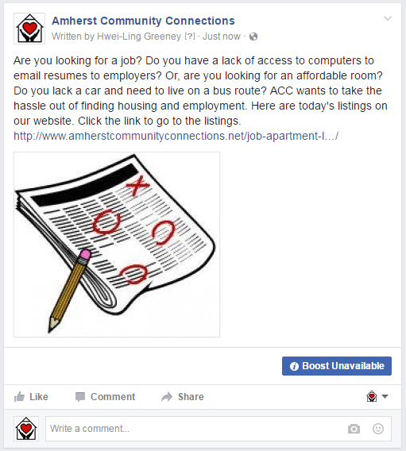
- To share on Twitter: (work in progress…)
- Simply click the share to twitter button on the posting directly from the website (if it’s there--sometimes it doesn’t work?) and add a caption!
  - If the share button is NOT there, then just use a link.
  - “ACC has taken the work out of your job or apartment search, check out our updated listings!”
- Same thing goes for posting any new “In the Limelight” posts!

